Contents

Main capabilities 1

Build Guide: 2

Chamber Frame: 2

Humidity System (Reservoir, Fan Mounts, Fans, SI7021 Temp/humidity sensor) 3

Lighting System: 7

Sample Heating System 8

Imaging System 9

Chamber Enclosure 10

Wiring 11

Software Initial Set Up 12

Script Pathing 13

Python Environment Set Up 13

Color Calibration (calibration_color_extraction.py) 14

Sample Temperature Calibration 14

Humidity Calibration 14

Data Logging/Beginning an Experiment (Humidity_Run_Script.py) 15

Data Processing (1. time_sync.py, 2. Image_processer.py, Color_transformation.py) 15

Maintenance Guide: 16

**Haverford Gen 2 Chamber Build Guide, Software/Operation**

# Main capabilities

* Humidity Range: from room humidity (approx. 25 %) to 85 ± 5 %
* Temperature Range: from room temperature to approx. 100 ± 2 °C
* Illumination Range: 0.15 ± 0.01 Sun (or 0-0.15 Sun with the supplementary version of the control program with intensity control, visible light only)
* Samples: Up to 9 samples placed on 10 mm diameter filter paper per sample holder
* Measurement Frequency: Limited by storage only

# Build Guide:

Note: This build guide is to be used in conjunction with the Haverford Chamber CAD Design. These steps will reference the 3D design, and not all parts of the chamber will be visible in the supplemental figures included below. Please use a CAD software that can visualize .STEP files so that you can follow along with the instructions, and query specific dimensions.

See the ChamberBOM spreadsheet for list of materials and possible sourcing options.

# Chamber Frame:

1. On your CAD software, navigate to the Aluminum Frame sub-assembly (Chamber Internals -> Humidity System). Hide all other assemblies.
2. Assemble the internal frame according to the color (Blue -> Red -> Green). Note: For the entire assembly process, **use spring-loaded, drop-in t-slot nuts**, so that you do not have to insert the nuts from the ends of the extrusion and the nuts remain in position while fastening.
3. Attach the Blue and Red extrusions together with the mounting brackets, t-slot nuts, and M5 x 8 Screws.
4. Attach the Green extrusions. The camera is mounted to the lower horizontal extrusion. The water reservoir for humidity control is mounted to the lower horizontal extrusion.

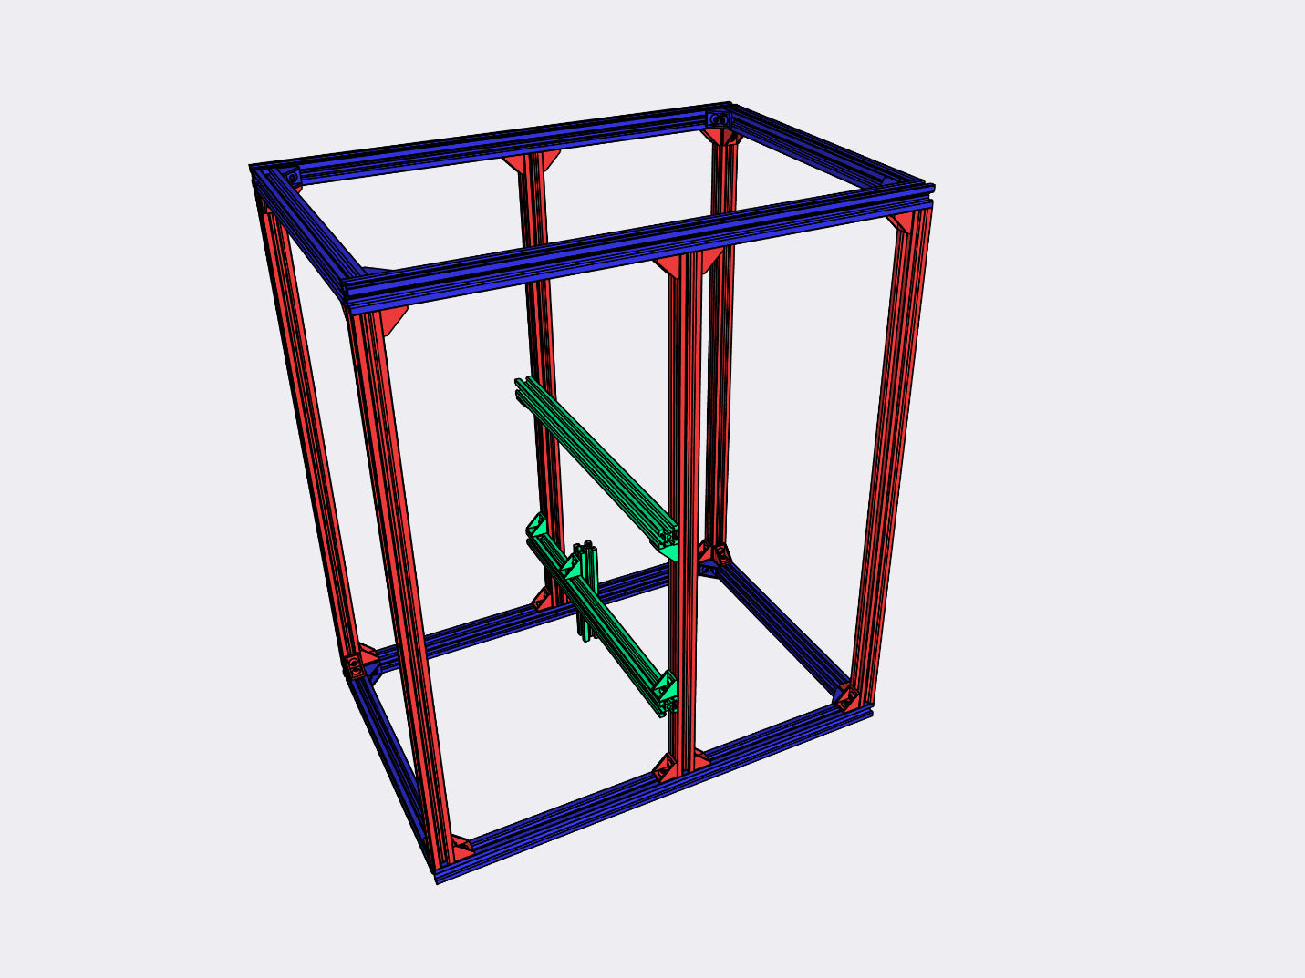

# Humidity System (Reservoir, Fan Mounts, Fans, SI7021 Temp/humidity sensor)

1. On your CAD software, navigate to the Humidity System sub-assembly, and toggle it back to visible. (Chamber Internals -> Humidity System).

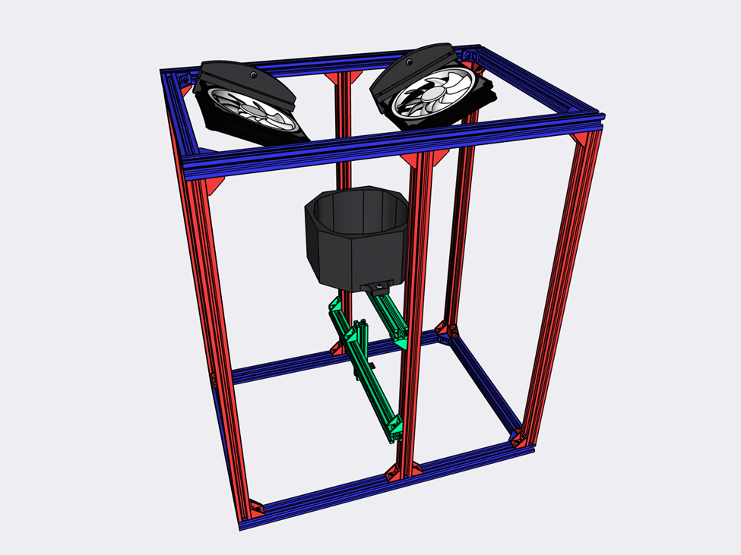

1. 3D-Print the Water Reservoir (located under the Humidity Reservoir sub-assembly), and the two fan mounts (located under the Humidity Reservoir Assembly -> Circulation Fan Left, and Circulation Fan Right sub-assemblies). We printed our parts in PETG on a Creality Cr10s Pro V2.

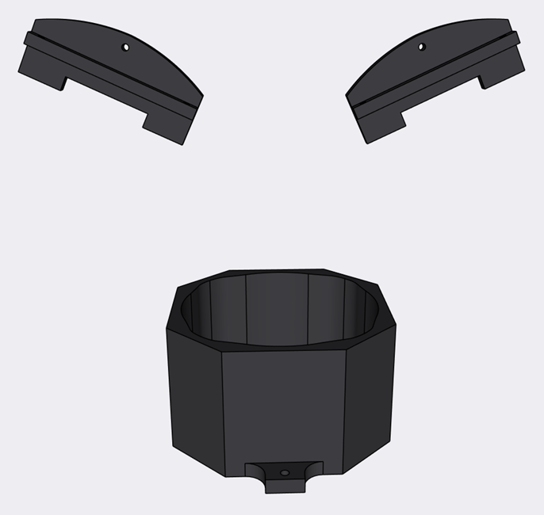

1. Using 2 M5 x 15 screws and drop in t-slot nuts, mount the Water Reservoir on the aluminum extrusion as shown in Figure Z1. There are two tabs on either end of the Water Reservoir for mounting. Then press fit the Noctua Silent Wings 140mm fan. Be sure to check that the air flow from the fan is directed out of the reservoir. The fan will only press fit in the correct orientation.

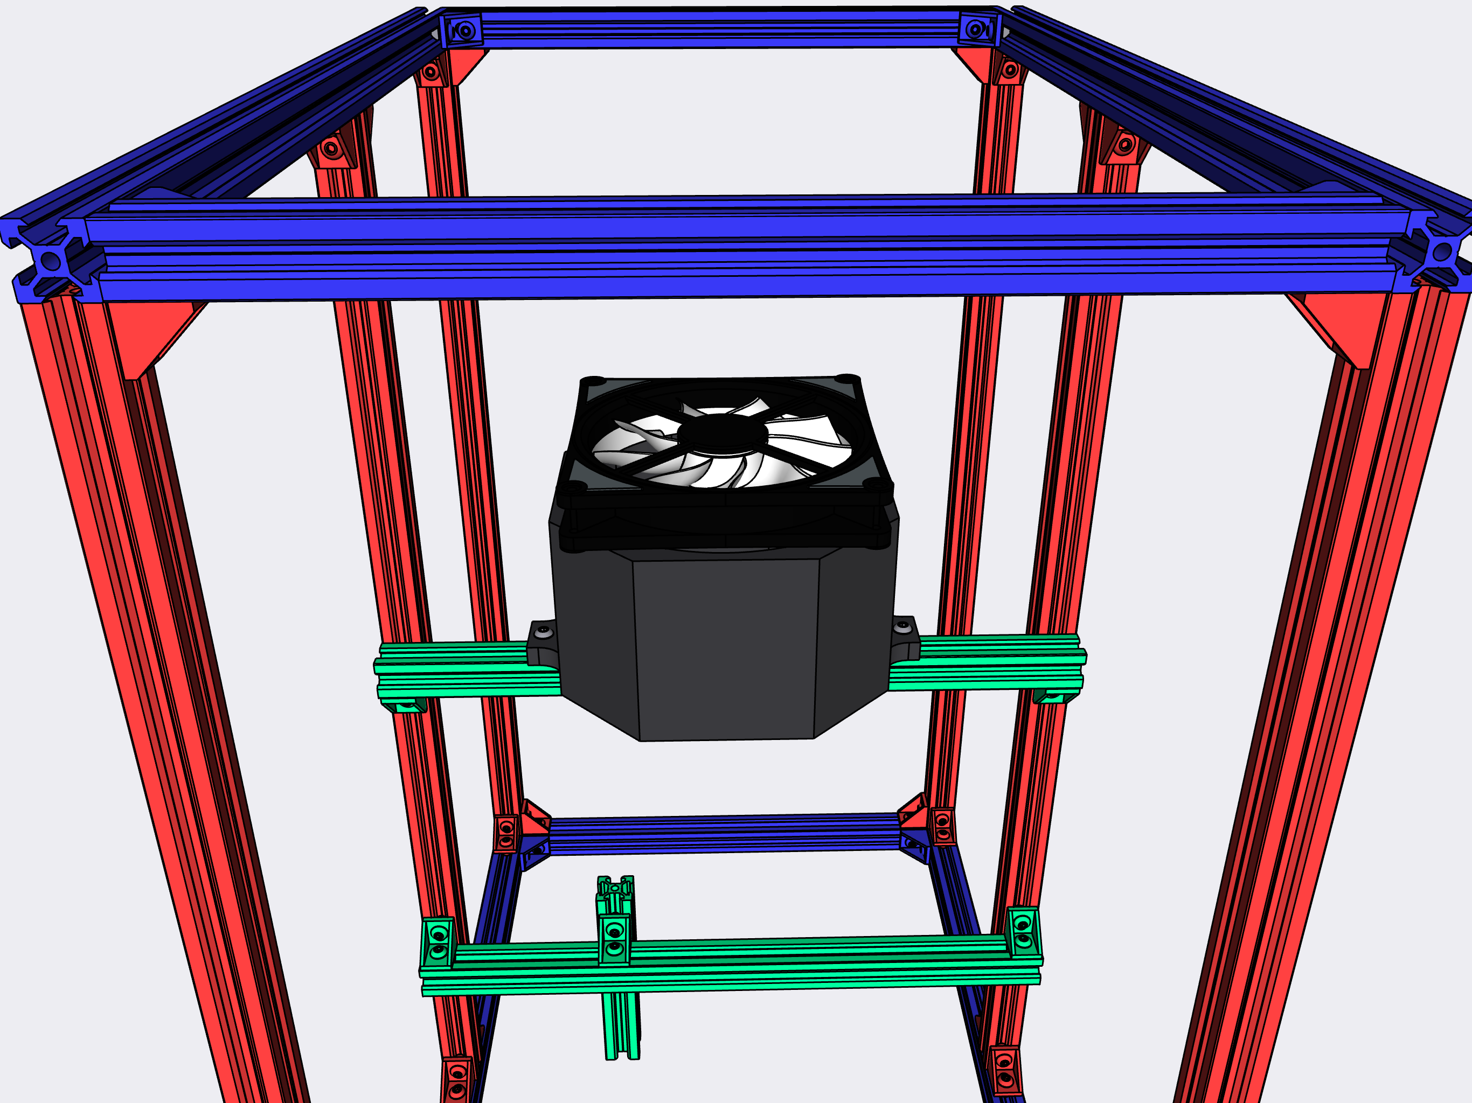

1. Mount the two remaining Noctua fans to the 3D printed fan mounts as shown in Figure Z2. Secure each fan to a fan mount using 2 M4x18 screws and a nut. There are mounting grommets that attach to the corner of each fan included with the Noctua fans. Attach the mounting grommets into two adjacent corners of the Noctua Fans. Pass the M4 x 18 screw through the Fan Mount, and then through the mounting grommets. Tighten a nut onto the ends of the threads.
2. Using 2 M5 x 15 screws and drop in t-slot nuts, mount the two fans in the positions indicated in Figure Z3.

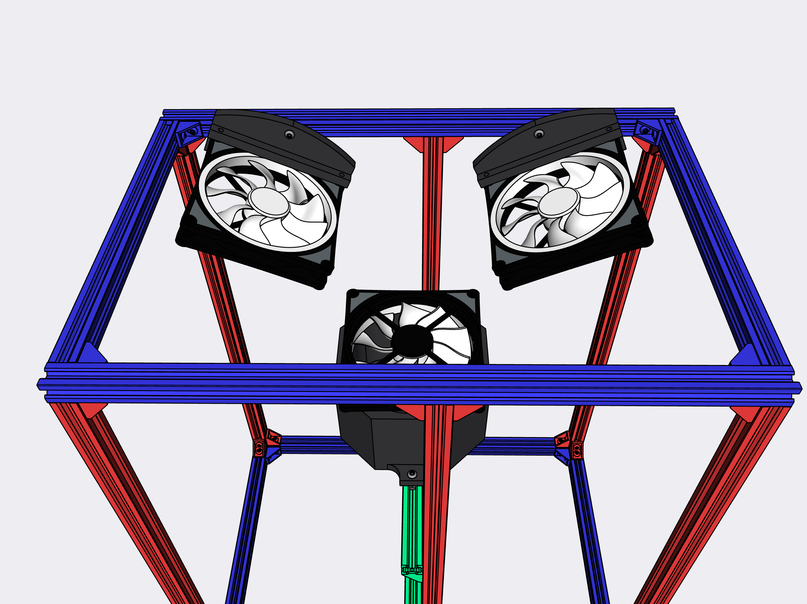

1. Secure the SI 7021 sensor to the aluminum extrusion as shown in Figure Z4. The exact placement and the method of attachment are not very important. The goal is to have the sensor be as close to the sample stage as possible. We secured the sensor in place using twist ties. Whatever method you use, be sure that it is easy to remove and reattach the sensors, as they will need to be replaced every 2-3 months. Before attaching the sensor, solder on the four header pins to assist in wiring in later steps.

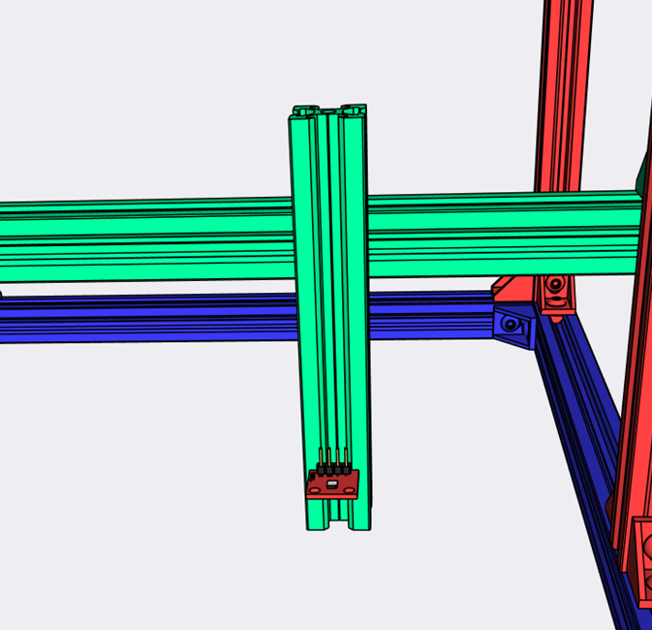

# Lighting System:

1. Remove the upper green extrusion the water reservoir is mounted on.
2. Thread two of the provided screws onto adjacent mounting points on the top of the Advanced Illumination DL097 Lamp. Tighten the screws such that the lamp can be slid onto the end of the aluminum extrusion and into position.
3. Reattach the extrusion holding both the water reservoir and the lamp back onto the frame.

# Sample Heating System

1. On your CAD software, navigate to the Sample Heating System sub-assembly, and toggle it back to visible. (Chamber Internals -> Sample Heating System).

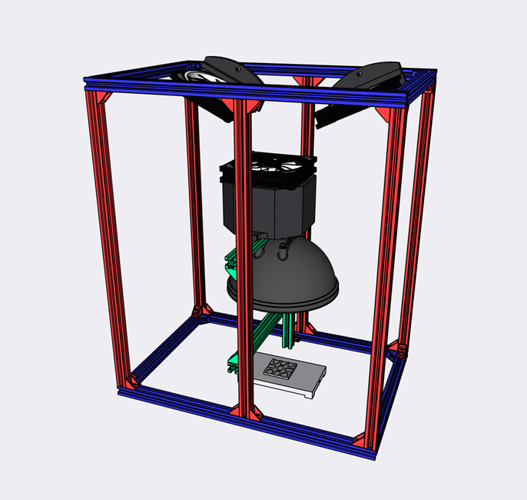

1. Machine or order the Heated Stage and the Sample Tray (A model for a blanked sample tray is also available if your sample geometry requires it).

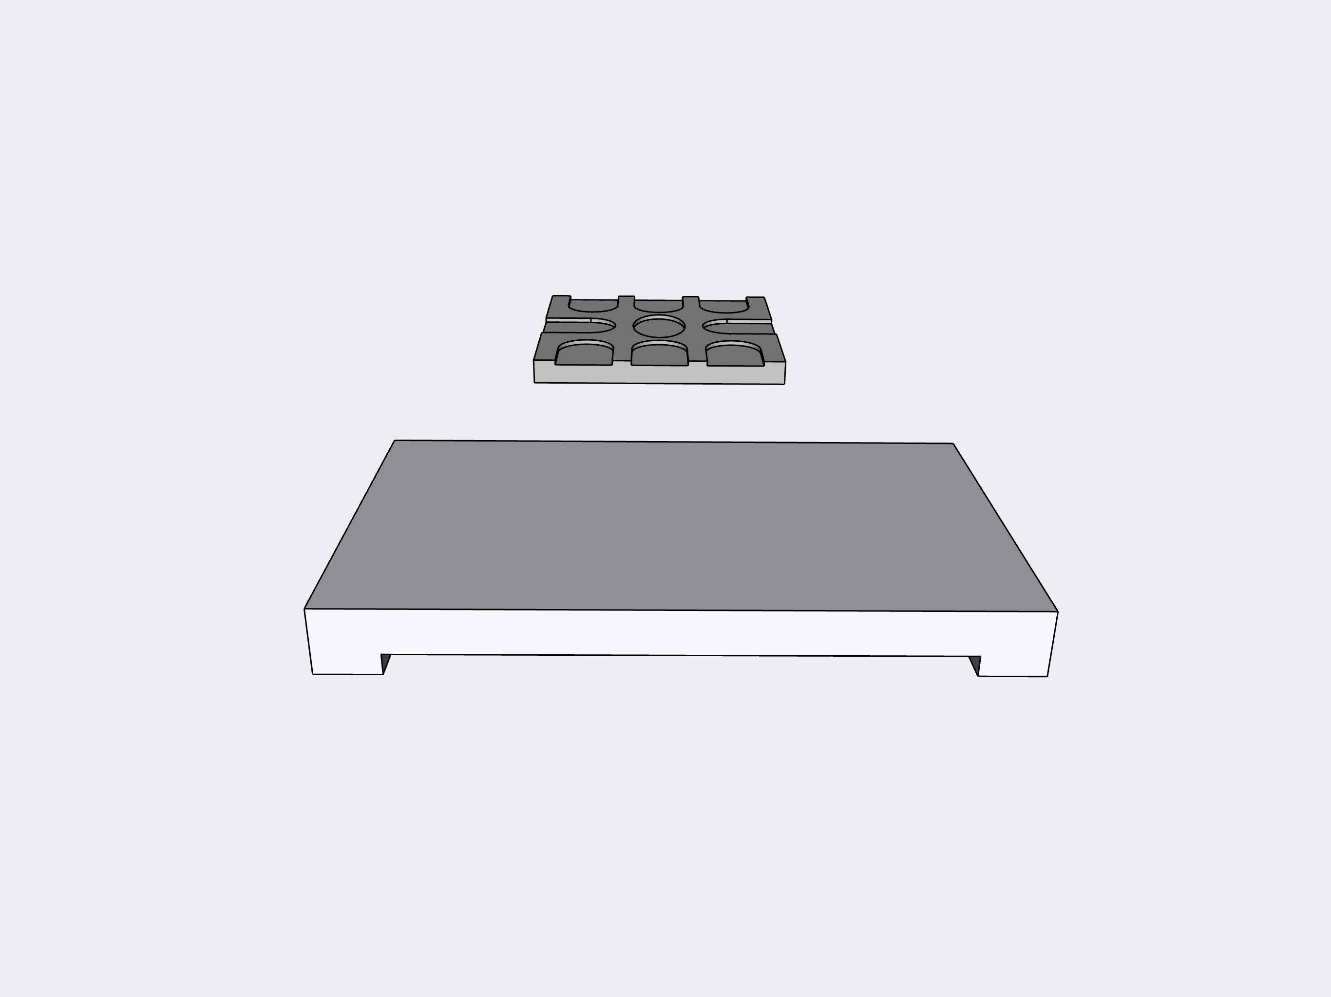

1. Coat the thermocouple with thermal paste and insert it into the heated stage in the bored-out slot.
2. Attach the silicone heater to the bottom of the heated stage. The wires from the silicone heater should face the same direction as the (Note, while not necessary at this time, it is easier to crimp connectors onto the silicone heater before sticking it onto the bottom of the stage.

# Imaging System

1. On your CAD software, navigate to the Acrylic Panels sub-assembly (Camera Assembly -> Enclosure Frame). Hide all other assemblies.
2. 3D-print the Camera L Bracket.
3. Attach the camera mount to the ThorLabs camera with the screws provided with the camera. Then mount the assembly to the aluminum extrusion using a t-nut and an M5x22 screw as shown in Figure Z6.

# Chamber Enclosure

1. On your CAD software, navigate to the Acrylic Panels sub-assembly (Chamber Enclosure -> Enclosure Frame). Hide all other assemblies.
2. Custom cut or order the panels (In the USA, we used sendcutsend.com).
   1. The Base Panel should be made in G10 – FR4 Fiberglass-epoxy laminate panel (“Garolite”), or equivalent material, at a thickness of 0.125”. This is to withstand the heat of the sample stage without warping.
   2. Order the door panel in ABS, at a thickness of 0.234”.
   3. Order the remaining panels in ABS,
   4. Make sure the panels are opaque, so that external light does not affect readings.
3. On your CAD software, navigate to the Enclosure Frame sub-assembly (Chamber Enclosure -> Enclosure Frame). Hide all other assemblies.
4. Using M5 x 8 screws, drop in t-slot nuts, and corner brackets, first assemble the base platform, the lower hoop, and the upper hoop (blue). Then attach the base frame and hoops to the corner extrusions (red).
5. Place strips of foam insulating tape on the faces of the aluminum extrusions of ABS panels that form the sample compartment. These ABS Panels are colored in green. (Note, this is only one method of sealing. Another method would be to use silicone sealant on the seams after chamber assembly. We preferred this method as it allowed for easy disassembly of the panels.)
6. Use the panels as a template to correct the final position of the base frame and bottom frame.
7. Cut the Water and Weather Resistant Foam

# Wiring

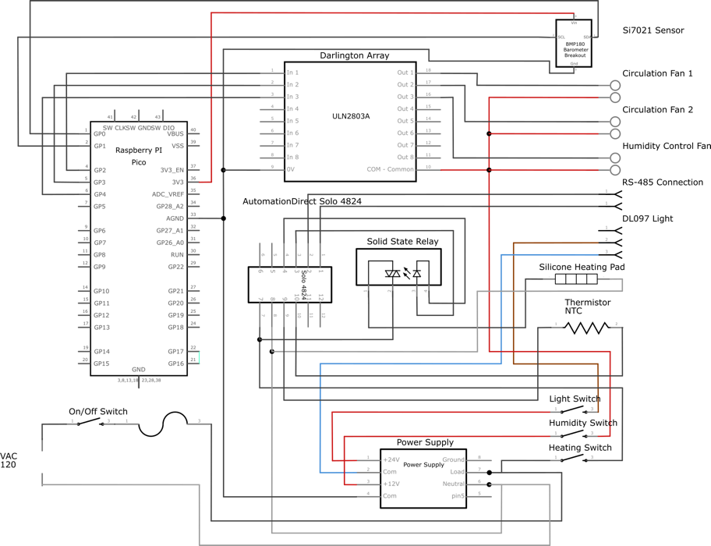

1. Follow the electrical diagram above to complete the wiring. Things to note: Wires from the chamber’s electrical components will need to be extended so that they can be routed through the baseplate hole, the mounting plate hole, and into the electronics compartment at the bottom of the enclosure. We found that it was easier to extend the wires further than you need, and then cable manage the excess (We extended the cables about 1 meter). All the 12-volt lines were extended by splicing a segment of 18-gauge stranded wire, and covering the soldered join with a shrink tube. The 110V line used 16 gauge stranded wire. The best practice for wiring up the chamber is to:
   1. Crimp or splice push fit terminals onto the SI7021 humidity sensor, the Noctua fans, the thermocouple, and the silicone heating pad. These connectors to do not have to be long. This allows the electrical components in the internal chamber to be easily disconnected from the outer enclosure. This is important for troubleshooting, maintenance and part replacement. The connectors we recommend are:
      1. SI7021: Solder on header pins. Connect to these with female breadboard wires, or a JST connector.
      2. Noctua Fans: These fans come with female JST ends, so no modification is necessary.
      3. Thermocouple: Crimp fork terminal connectors to the end of the thermocouple wires.
      4. Silicone Heating Pad: Crimp female spade connectors to the ends of the wires.
      5. DL097 Lamp: Crimp fork terminal connectors to the ends of the brown and blue wire. The white wire is unused.
   2. Measure out and cut 1 meter of wire for each of the components. These wires will act as extensions that allow the user to connect the electrical component in the internal chamber to the chamber enclosure. On one end of the wires, crimp on a matching connector. On the other end, crimp on a connector than can pair with the associated component in the internal enclosure.
2. Wire all the components in the electrical compartment of the enclosure. This includes the power supply, toggle switches, Raspberry Pi Pico, Solo Temperature Controller, solid state relay (SSR-40DA), power plug, and the extension cables prepared in the previous step. Use the ABS panel as a mounting board for the electronic components, and for cable management. Holes were drilled as necessary to insert twist ties to manage excess lengths of wires. We crimped fork connectors onto all wires that had to be attached to the Solo Temperature Controller, power supply, solid state relay. Circular terminals were used for wires that
   1. See section 7 of the manual linked below for an extra figure to correlate with the wiring diagram to assist with the connection of the Solo 4824-VR.

<https://cdn.automationdirect.com/static/manuals/solocontrolm/solosl4824qsg.pdf>.

1. Route the extension cables for the internal components (Fans, sensors, heating pad, etc.) through the circular hole in the Base Panel and Electronics Panel.
2. Connect the extension cables to their respective components.
3. Cable-manage the excess within the electrical compartment of the enclosure
4. Connect the RS-485 to USB cable, the Thorlabs Camera USB, and the Pico microcontroller USB into a host laptop.
5. Connect the Chamber power plug into the wall, and turn on the on/off switch.
6. Set the three toggle switches to the “on” position. If wired correctly, the lamp and Solo Temperature Controller will turn on. The fans will not yet turn on, as the Pico needs to be flashed with the humidity control script.

# Software Initial Set Up

1. First download the prerequisite software
   1. ThorLabs Camera Software (For time-lapse image collection)

<https://www.thorlabs.com/software_pages/ViewSoftwarePage.cfm?Code=ThorCam>

* 1. Thonny (For ambient temperature and humidity logging via raspberry pi pico)

<https://thonny.org/>

* 1. Automations Direct Solo Configuration Software (For sample temperature recording)

<https://www.automationdirect.com/adc/shopping/catalog/software_products/process_control_-a-_measurement_software/sl-soft>

1. Go to the chamber’s Github page, and clone the repository. Example experimental data and calibration data has been included as an example of expected input and folder hierarchy:

https://github.com/rodolfokeesey/Haverford_Environmental_Chamber

# Script Pathing

These chamber scripts are meant to work with the following folder structure:

/Chamber Data # root for all the chamber data. This is the path you enter for chamber_data_path. You

# can place this folder wherever. A sample folder is included in the repository as

# Chamber_Test_folder with one example experiment.

/RK_37 # example experiment run. This folder is a placeholder, the raw data is too large to

# post on github but can be downloaded here.

/Color_Calibration_5_6_22 # Folder storing the two Xrite Color Checker Images

/Video_Queue # The temporary file that where the time lapse .avi video from the Thorlabs

# application is saved

/Sample_Temp_Queue # The temporary file that where the .txt log from the Automation's

# Direct Solo Configuration application is saved

# Python Environment Set Up

These codes have been tested in Windows 10 in anaconda using Spyder.

1. Download and install anaconda for windows
2. Download (if you do not already have) the chamber data processing codes.
3. Through the anaconda terminal, navigate to the location of the downloaded files
4. Deactivate any current conda instance
5. Create a new python 3.7 environment:

conda create -n aging_chamber python=3.7

1. Activate the new environment

conda activate aging_chamber

1. Install the necessary python packages using pip

pip install -r requirements.txt

1. Through the Anaconda Navigator, install Spyder 5.1.5.

# Color Calibration (calibration_color_extraction.py)

1. Before beginning chamber use, the color calibration reference photos of the XRite Color Checker must be taken.
2. Take two photos of the Xrite Color Checker. The orientation of the photos must match the included examples. Adjust the focus and the height of the camera until the color checker is in focus.
3. Once the two calibration photos have been taken, run the calibration_color_extraction.py script, and follow the prompts.

# Sample Temperature Calibration

The sample tray (located atop the heated stage) temperature was calibrated against the thermocouple (located within the heated stage) using melting point standards to account for the insulating effect of the sample tray and filter papers.

1. Place melting point standards within the range of 0-100C (we calibrated with Vanillin and Benzophenone) onto nine 10 mm filter papers.
2. Place each filter paper containing melting point standards on each of the nine wells of the sample holder.
3. Using the Thorlabs Camera Application’s real time view and the digital readout of the Solo Temperature Controller, begin slowly increasing the temperature of the sample holder until the standards melt.
4. Record the offset between the Solo Temperature Controller’s readout, and the expected melting temp (We stored this offset as a dated CSV file in the Chamber_Data folder). Use this offset to calibrate the final temperature setting of the Solo Temperature Controller during experiments.

# Humidity Calibration

1. Use the Thorlabs Camera Application to view the chamber in real time. Set up a humidity logger within frame of the camera.
2. Turn on the humidity control system toggle switch and close the chamber doors. Run the Humidity_Run_Script.py in Thonny.
3. Note the offset between the values outputted in Thonny’s terminal with those observed on the humidity logger through the camera. Adjust the target humidity on the Pico humidity script to account for this difference.

After all calibration is completed, the Aging Chamber is ready for use.

# Data Logging/Beginning an Experiment (Humidity_Run_Script.py)

1. To begin an experiment, start by connecting the aging chamber. To connect to the aging chamber, first ensure the Pico’s USB cable is connected to the host laptop. Then open the Thonny application, and run the Humidity_Run_Script in Thonny. This script creates an experiment folder, and records the ambient temperature and humidity within the chamber. If the chamber is connected properly, you will see numerical data stream outputted in the Thonny Shell. The sample holder temperature and images are recorded by the Solo Configuration application and the ThorCam application, respectively. Before beginning an experiment, be sure that the humidity reservoir is filled with water. Try to preheat the chamber for at least four hours in advance. To preheat the chamber, simply turn all three toggle switches on, and set the sample temperature via the Solo 4824 controller.
2. End the script once the desired aging time has been reached. The end the video capture from the ThorCam application, and disconnect from the Solo 4824 to end sample temperature recording. Then transfer the file from the Solo Configuration, and the video from the ThorCam application into the newly created experiment folder. After the data logging for a run is completed, there should be three files within an experiment folder (for example see, RK_37):

- An .avi video file, the default filename is "image_0.avi"

- A humidity log .txt file, the default filename is "humidity_temp_data.txt"

- A sample holder temperature log .txt file, the default filename is "Sample_Temp_Queue"

# Data Processing (1. time_sync.py, 2. Image_processer.py, Color_transformation.py)

1.) After terminating the Humidity_Run_Script, and moving the video file and the sample holder log file into the experiment folder, open the time_sync.py script in an environment with the chamber dependencies. Fill out the User Inputs section, then run the script. This script will read all of the log files, break the timelapse video into individual frames for RGB analysis, and sync the sensor timing with the image capture. It will also generate a graph with the chamber's ambient temperature, relative humidity, and the sample holder temperature for the duration of the experiment.

2.) Next open the Image_processor script. Fill out the User Inputs section, then run the script. This script will go well by well of the sample holder, create a mask using the blanked well as reference, isolate the bulk crystals in the well, then extract the RGB Values. Once all the wells have been processed, the raw RGB values are transformed using the Color_transformation.py script. The final output is a .png image of the RGB change over time and a CSV of the RGB data for each well.

# Maintenance Guide:

Humidity Calibration: Replace the SI7021 once a month under heavy usage, or once the SI7021 reported humidity deviates more than 10% RH from the humidity logger.

Color Calibration: If any modifications are made to the lamp positioning, or sample positioning that will affect illumination quality, repeat the Color Calibration step. The XRite ColorChecker Passport manufacturer also recommends replacement every 18-24 months due to color fade.

Routine Checking: Between longitudinal tests, inspect the chamber for any leakages in the humidity reservoir, or pools of water from condensation. Some water build up is acceptable, so long as it is not in proximity of any electrical components.

Windows Updates: In order to prevent windows updates from restarting the data logging computer during operation, set the computer to airplane mode, and turn off automatic updates.

Storage Space: Be sure to monitor storage usage of the laptop. Once the laptop begins to runout of storage, offload experiments into cloud storage, or an external hard drive.